**CDS VIEW with ODATA with Two Options**

ODATA for CDS View can be created in two ways either by invoking the CDS view in the (1) Gateway service Builder or directly from the (2) CDS view using the CDS Annotation.

**Method 1**: **Create ODATA using Gateway Service Builder by referring Data Source as CDS View.**

Right Click on Project->Click on New->Click on Others

Expand ABAP and Scroll Down to Core DATA services.

Choose Data Definition and Click on Next Button.

Enter the Package Name, CDS View Name and Description and Click on Next button.

Create or choose the Transport and Click on Finish.

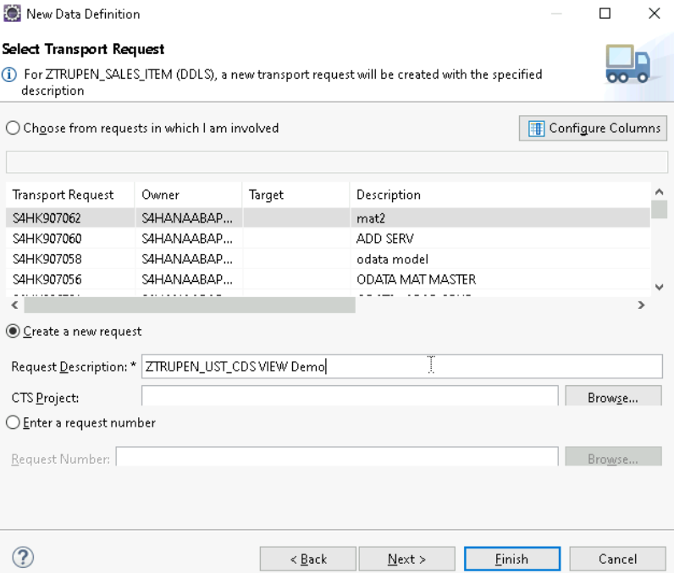

CDS View can be defined by selecting the item data from VBAP table. Save and activate the CDS View.

Create the Header CDS View by Navigating to the Package -> Expand the Package -> Core Data Services->Data Definitions->Click on New Data Definition.

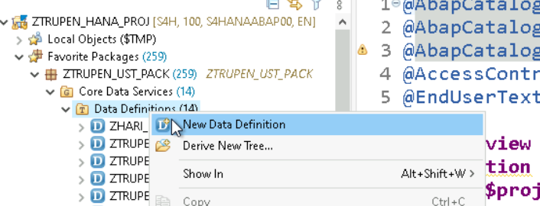

Now Provide the Package Name, CDS View name and Description and Click on Next button.

Create the Transport or choose the Transport from the list shown and Click on Finish button

CDS View can be defined by selecting the item data from VBAP table. Save and activate the CDS View after selecting the data.

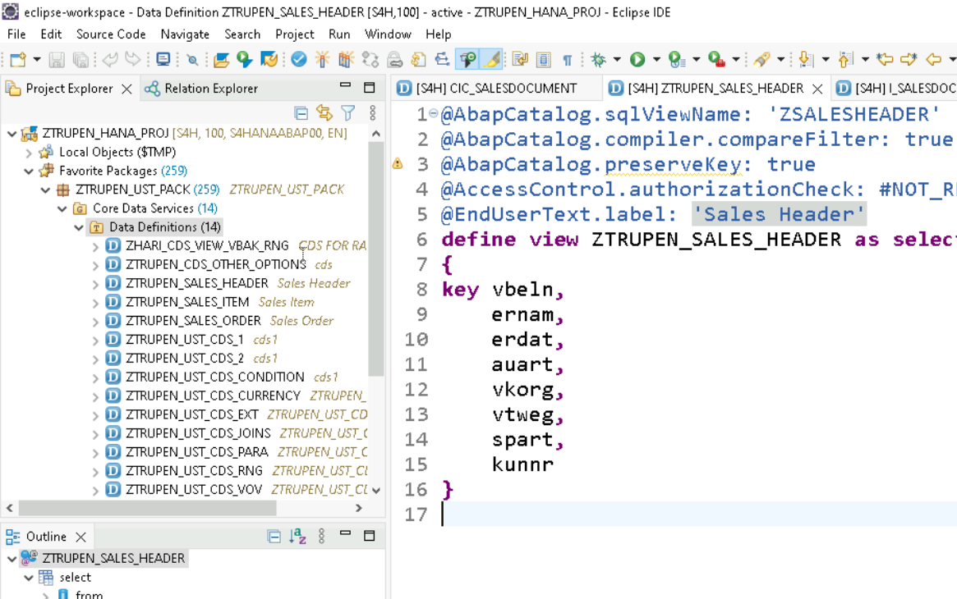

Similarly Create Another CDS View by Navigating to the Package -> Expand the Package -> Core Data Services->Data Definitions->Click on New Data Definition



Provide the Package Name, CDS View Name and Description and Click on Next Button.

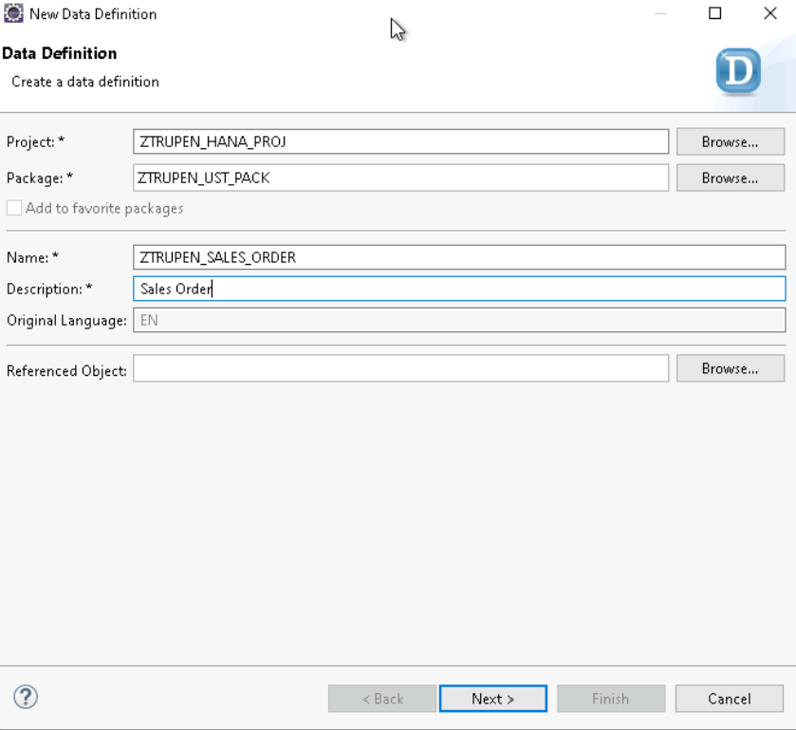

Create or choose the Transport from the shown List and Click on Finish.

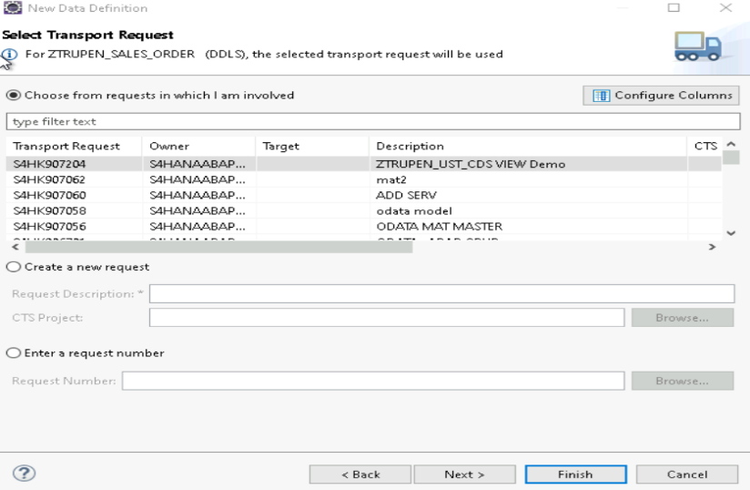

CDS View can be defined by selecting the data from Header CDS View and associate to ITEM CDS View on the field Sales Order. Save and activate the CDS View after selecting the data.

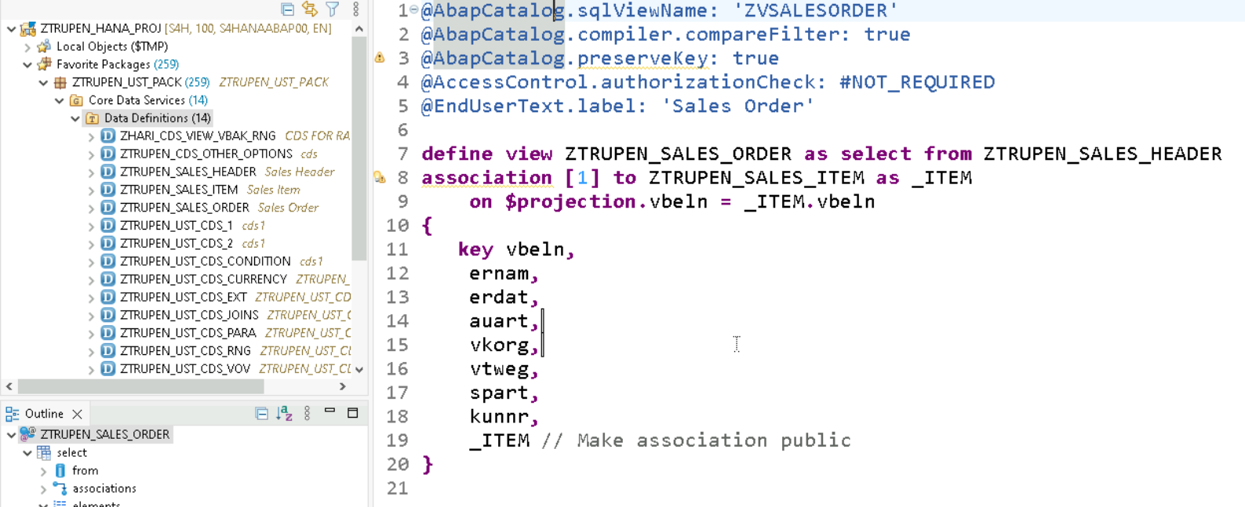

**Code Snippet:**

**CDS View :** ZTRUPEN_SALES_HEADER

@AbapCatalog.sqlViewName: 'ZSALESHEADER'

@AbapCatalog.compiler.compareFilter: true

@AbapCatalog.preserveKey: true

@AccessControl.authorizationCheck: #NOT_REQUIRED

@EndUserText.label: 'Sales Header'

**define** **view** ZTRUPEN_SALES_HEADER **as** **select** **from** vbak

**{**

**key** vbeln**,**

ernam**,**

erdat**,**

auart**,**

vkorg**,**

vtweg**,**

spart**,**

kunnr

**}**

**CDSVIEW: ZTRUPEN_SALES_ITEM**

@AbapCatalog.sqlViewName: 'ZSALESITEM'

@AbapCatalog.compiler.compareFilter: true

@AbapCatalog.preserveKey: true

@AccessControl.authorizationCheck: #NOT_REQUIRED

@EndUserText.label: 'Sales Item'

**define** **view** ZTRUPEN_SALES_ITEM **as** **select** **from** vbap

**{**

**key** vbeln**,**

**key** posnr**,**

matnr**,**

@Semantics.amount.currencyCode: 'Waerk'

netwr**,**

@Semantics.currencyCode: true

waerk**,**

werks**,**

lgort

**}**

**CDS View: ZTRUPEN_SALES_ORDER**

@AbapCatalog.sqlViewName: 'ZVSALESORDER'

@AbapCatalog.compiler.compareFilter: true

@AbapCatalog.preserveKey: true

@AccessControl.authorizationCheck: #NOT_REQUIRED

@EndUserText.label: 'Sales Order'

**define** **view** ZTRUPEN_SALES_ORDER **as** **select** **from** ZTRUPEN_SALES_HEADER

**association** **[**1**..*]** **to** ZTRUPEN_SALES_ITEM **as** _ITEM

**on** **$projection.**vbeln **=** _ITEM**.**vbeln

**{**

**key** vbeln**,**

ernam**,**

erdat**,**

auart**,**

vkorg**,**

vtweg**,**

spart**,**

kunnr**,**

_ITEM // Make association public

**}**

**GATEWAY SERVICE CREATION FOR CDS VIEW USING SEGW**

Open the Gateway Service builder using **SEGW** Transaction and Click on Create Button.

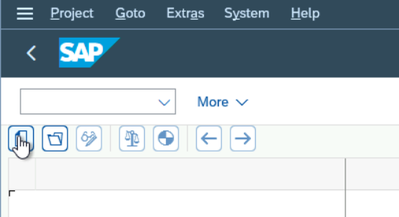

Provide the Project name, Description and Package Name and Click on Enter.

The Project is created and Right click on Data Model->Click on Reference-> click on Data Source

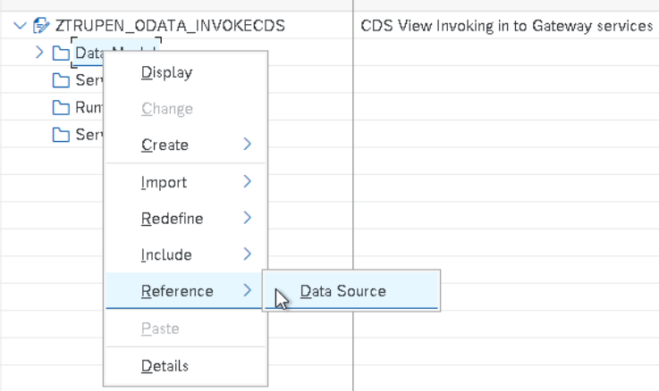

Mention the CDS View Name in the CDS View Entity and Click on next.

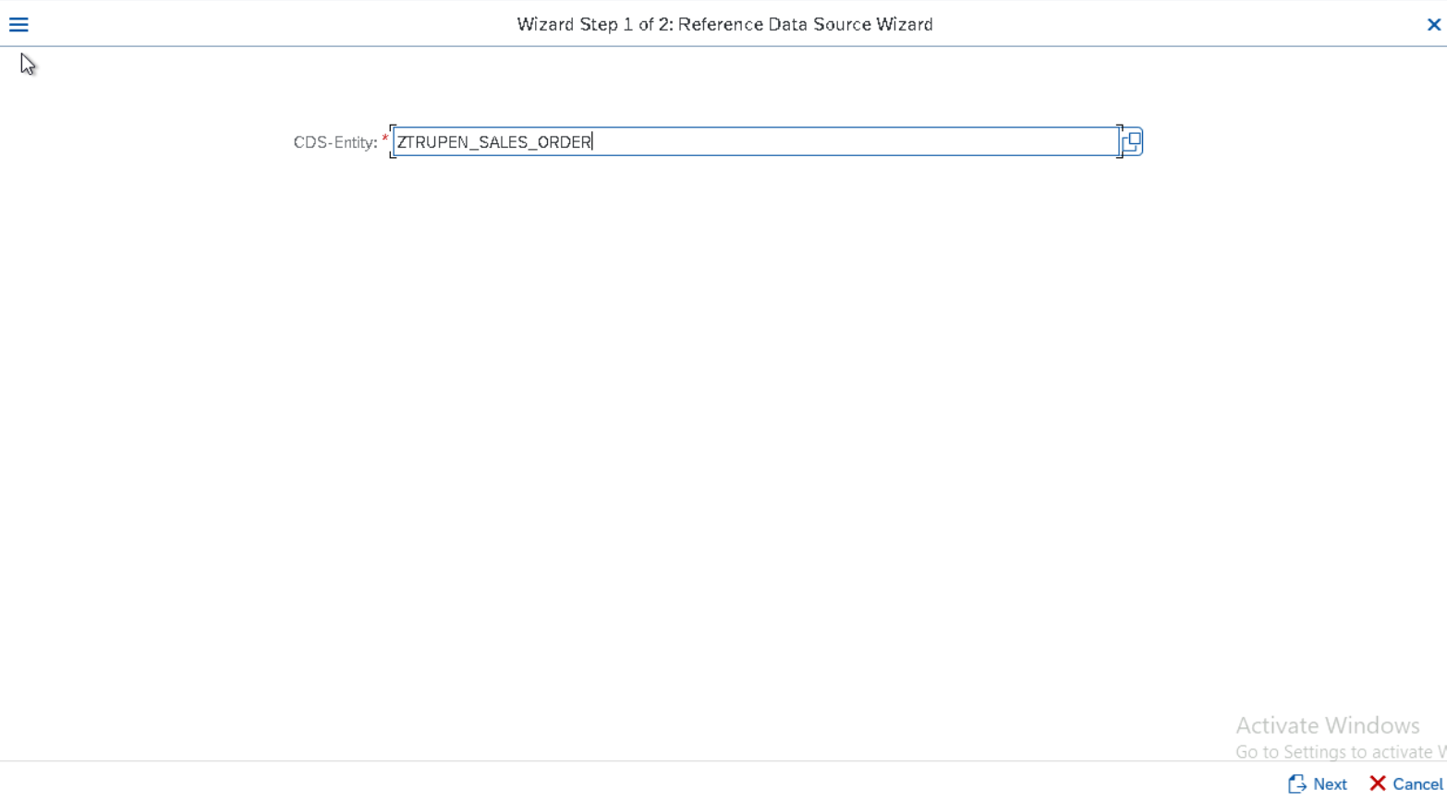

The CDS Entity Provided and its associated CDS View entity is listed now and we can select the required entity from the List shown and click on Finish Button.

Provide the TR number and Click on Enter.

Now we could see that System Automatically created the Entity types and Entity sets and Association and Association sets based on the Association defined in the CDS View.

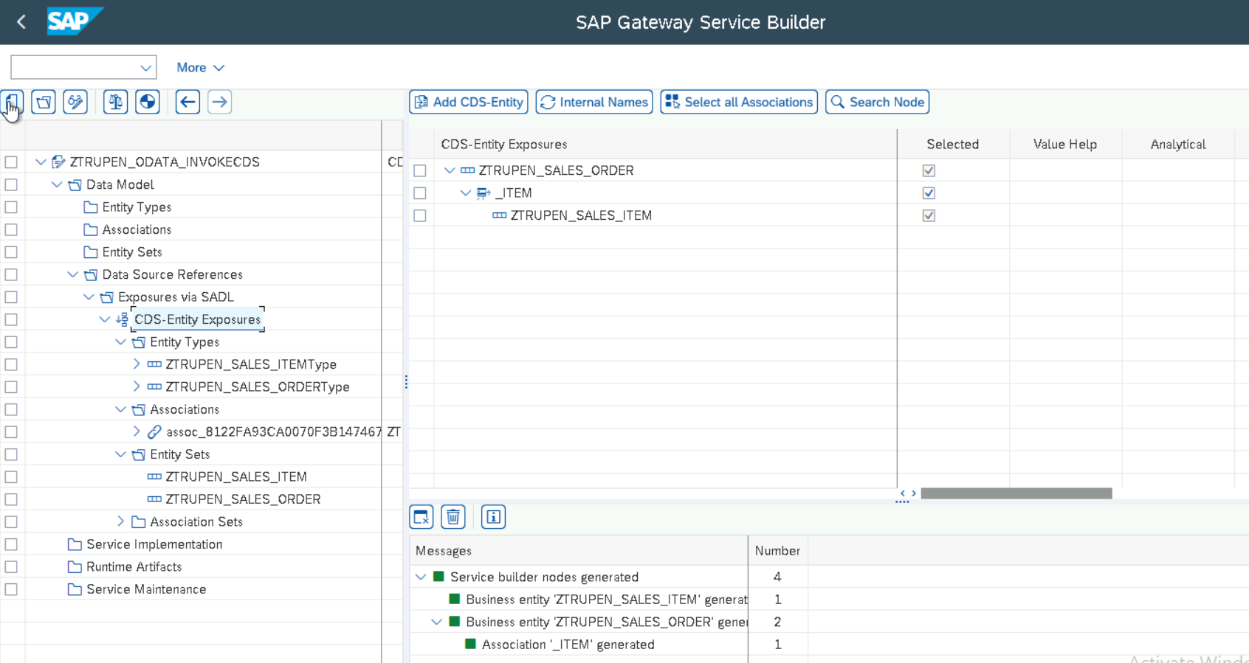

Generate the Runtime Objects by clicking on the Icon Generate Runtime Objects Icon.

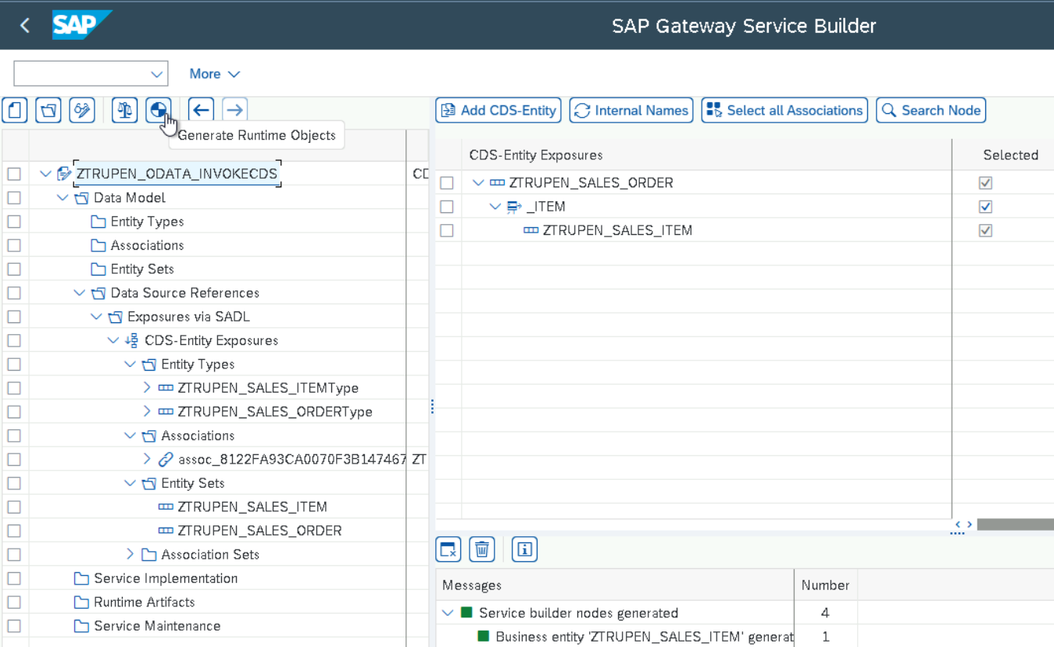

System proposes Class name for the Data provider and Model Provider and Technical Model and Service name by default and can be modified according to the Customer Namespace and Click on Enter.

Provide the Package Name for the Class and Click on Save

Provide the Transport Number for the Class and Click on Enter.

Double click on the Runtime Artefacts and check the Generated objects.

**GATEWAY SERVICE Activation-** Go to Transaction /IWFND/MAINT_SERVICE ->Click on Add service

Provide the System Alias and Technical Service name generated during Runtime Object generation and Click on Add Selected Services.

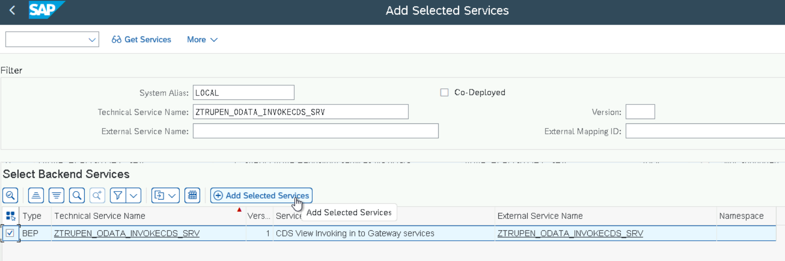

Click on Enter.

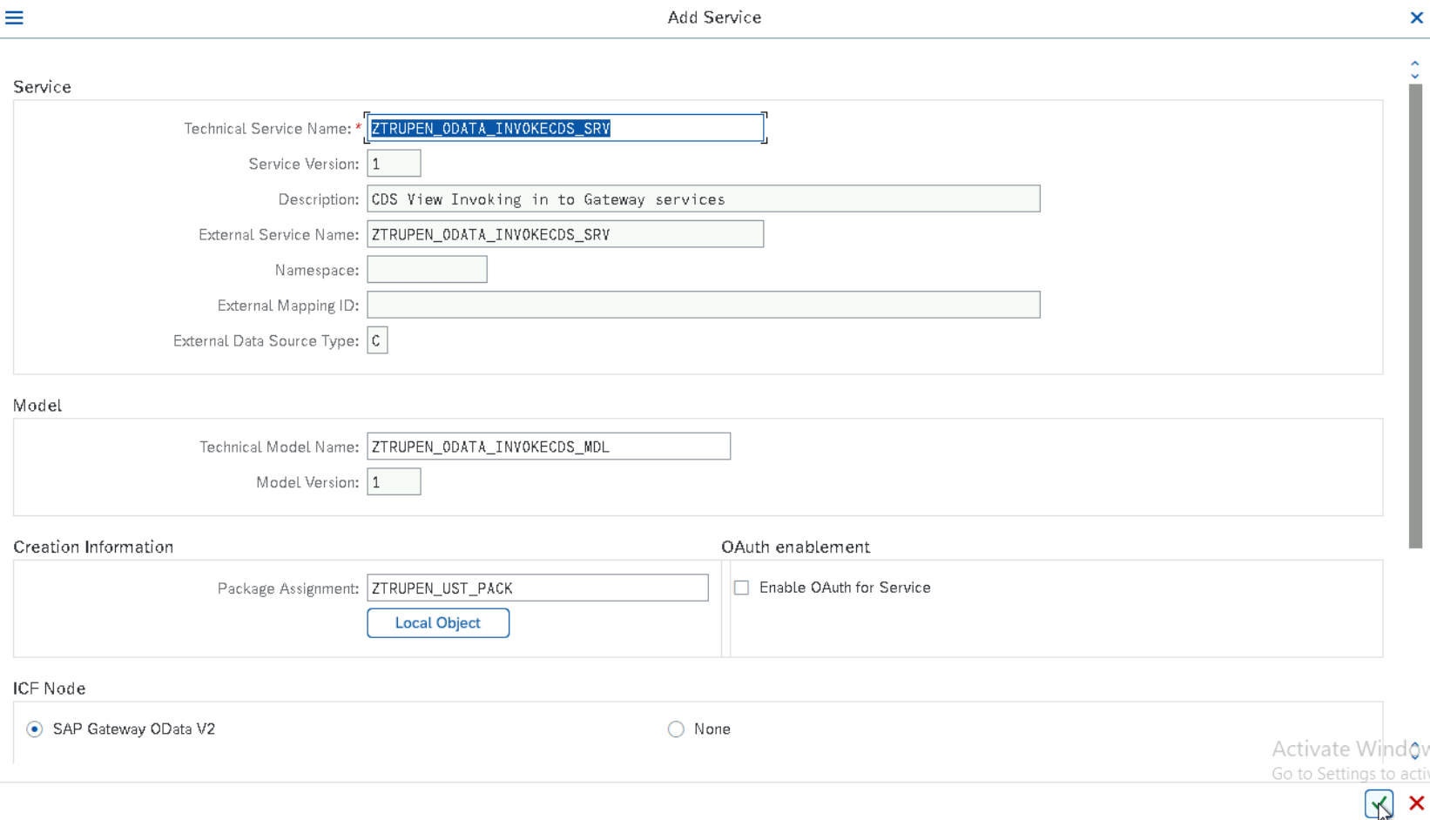

Provide the Transport Number for Metadata and click on Enter.

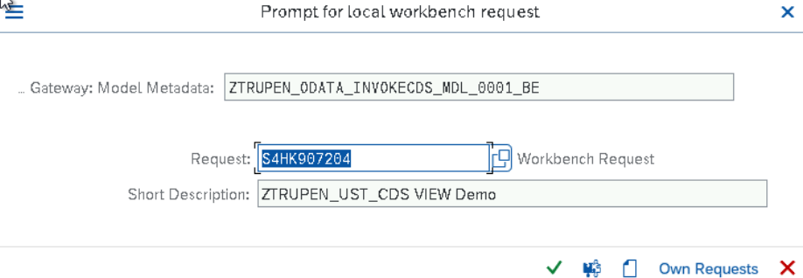

Provide the Transport number for ICF Service and Click on Enter.

Click on Filter Button.

Provide the Technical Service Name.

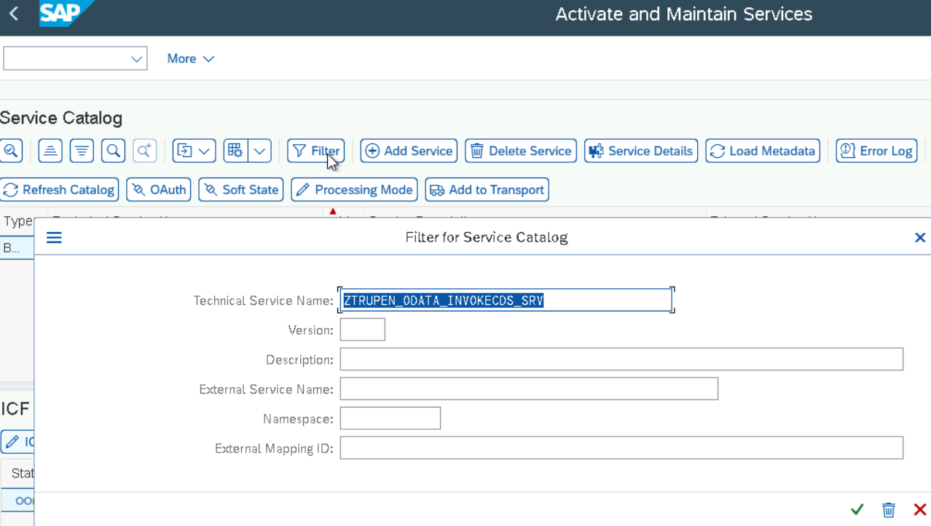

The Service is opened now and Click on Configure SICF Node to deactivate the CSRF Token Validation.

Double click on the Service now to maintain the Parameter.

Go in Change Mode and Click on GUI Configuration under the Service Data.

Maintain the Parameters for the CSRF Token and Click on Enter and Save.

Click on Execute SAP Gateway Client

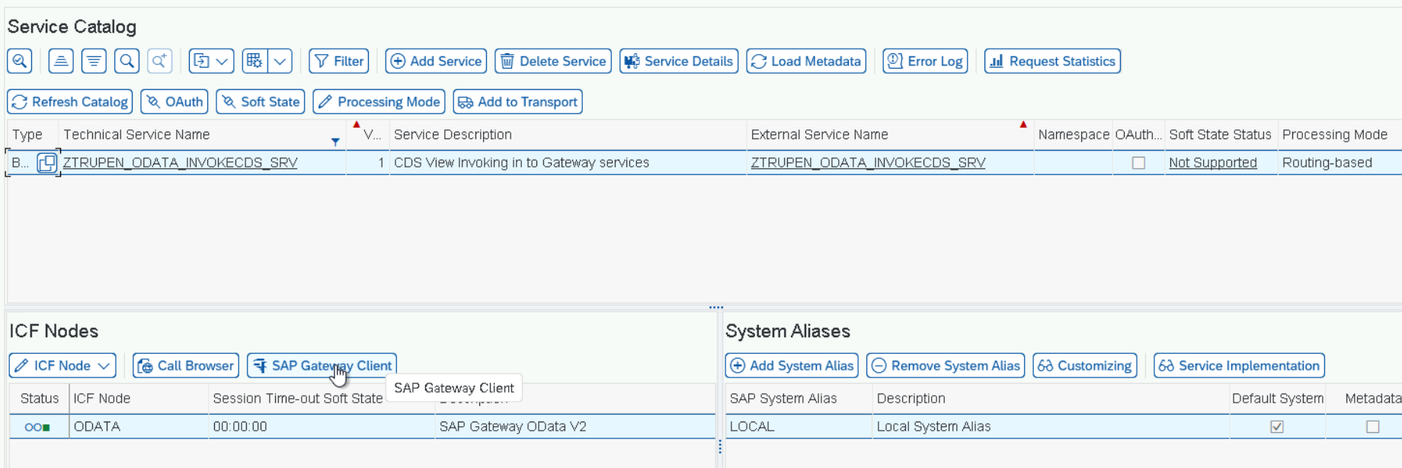

Now the ODATA Service is executed to check the List of Entity sets.

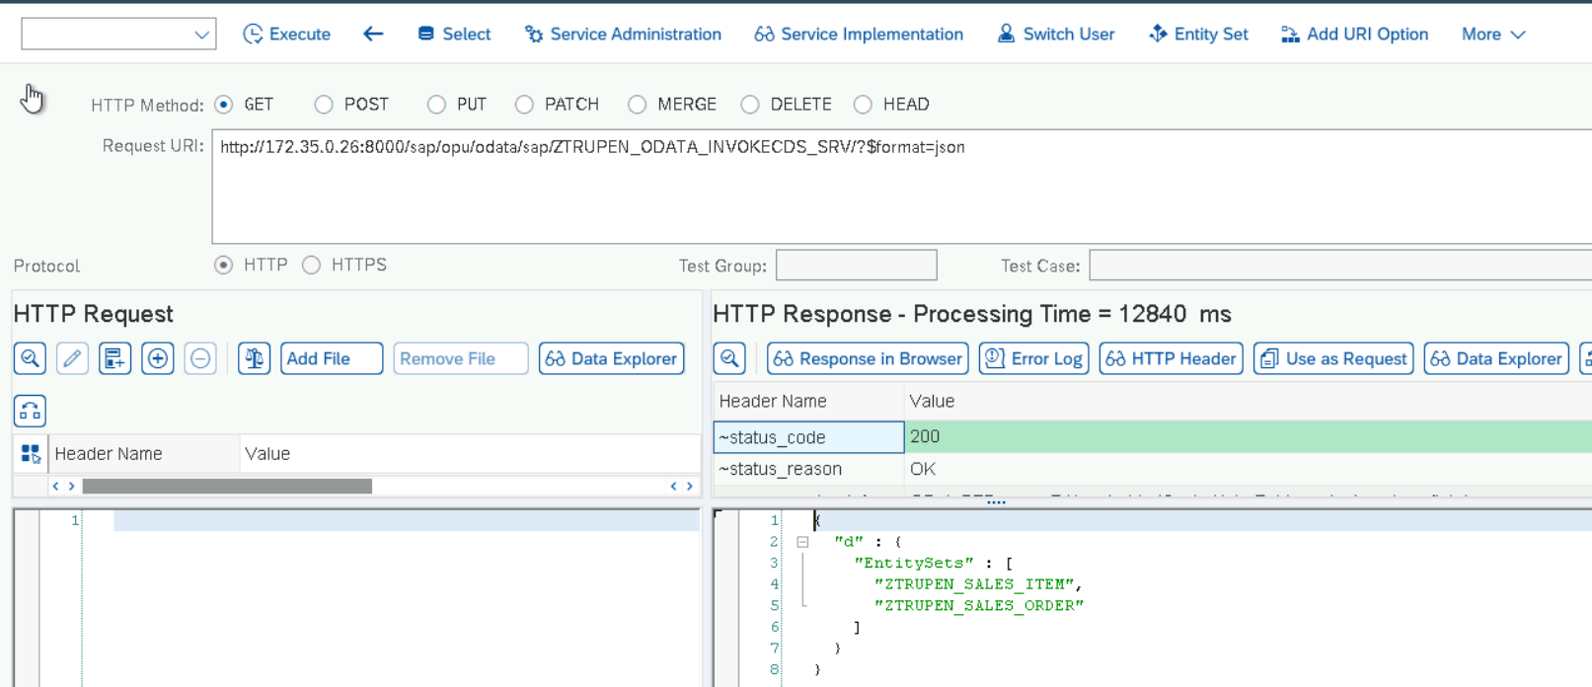

**TESTING**

**URI :** http://172.35.0.26:8000/sap/opu/odata/sap/ZTRUPEN_ODATA_INVOKECDS_SRV/ZTRUPEN_SALES_ORDER('0000001946')

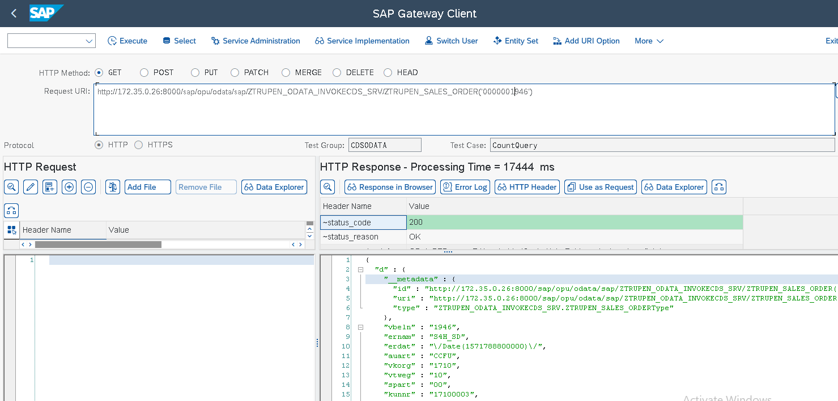

**Method 2: Create ODATA Service Using CDS Annotations**

Create Another CDS View by Navigating to the Package -> Expand the Package -> Core Data Services->Data Definitions->Click on New Data Definition



Create CDS View to check the ODATA created from the CDS View using Annotation by providing Package, Name and Description and click on Next Button.

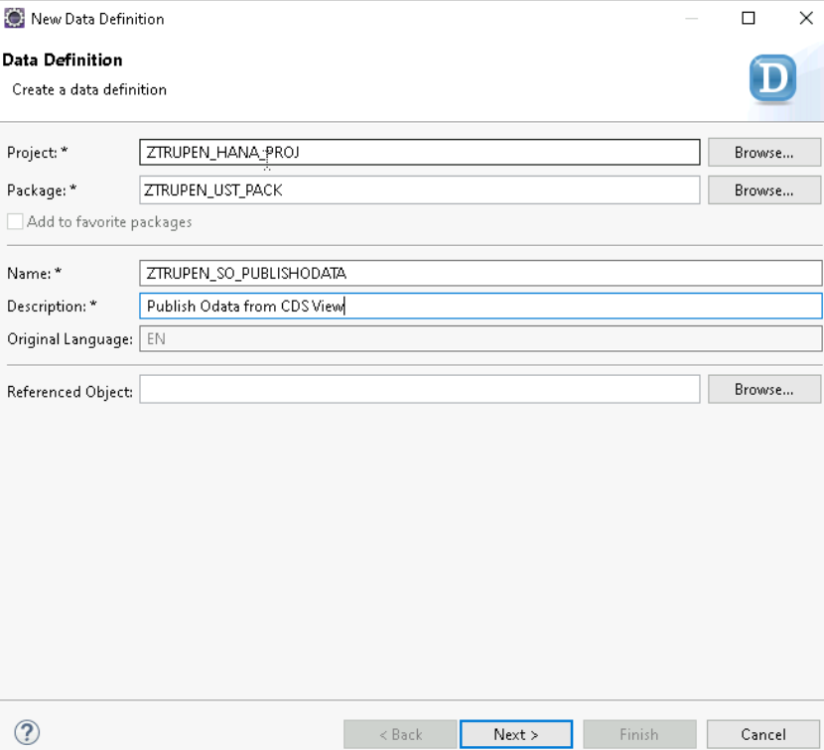

Create the Transport or provide the Transport number and click on Finish

Define the CDS View by selecting the header data from CDS view ZTRUPEN_SALES_HEADER and Associate with the ITEM CDS View ZTRUPEN_SALES_ITEM. The Annotation ODATA.Publich: true generates the ODATA Service with Service name as <CDSVIEWname>_CDS.

**CODE SNIPPET:**

**CDS View :** ZTRUPEN_SO_PUBLISHODATA

@AbapCatalog.sqlViewName: 'ZVSALESORDER1'

@AbapCatalog.compiler.compareFilter: true

@AbapCatalog.preserveKey: true

@AccessControl.authorizationCheck: #NOT_REQUIRED

@EndUserText.label: 'Publish Odata from CDS View'

@OData.publish: true //Create OData From the CDS View

**define** **view** ZTRUPEN_SO_PUBLISHODATA **as** **select** **from** ZTRUPEN_SALES_HEADER **association[**0**..*]** **to**

ZTRUPEN_SALES_ITEM **as** _ITEM

**on** **$projection.**vbeln **=** _ITEM**.**vbeln

**{**

**key** vbeln**,**

ernam**,**

erdat**,**

auart**,**

vkorg**,**

vtweg**,**

spart**,**

kunnr**,**

_ITEM // Make association public

**}**

**Service Activation**

Service can be activated using the Transaction /IWFND/MAINT_SERVICE.

Add the System Alias as LOCAL and mention the technical service name as ZTRUPEN_SO_PUBLISHODATA_CDS and Click on Enter.

Select the Service and Click on Add selected Services.

Assign the Package and Click on Enter.

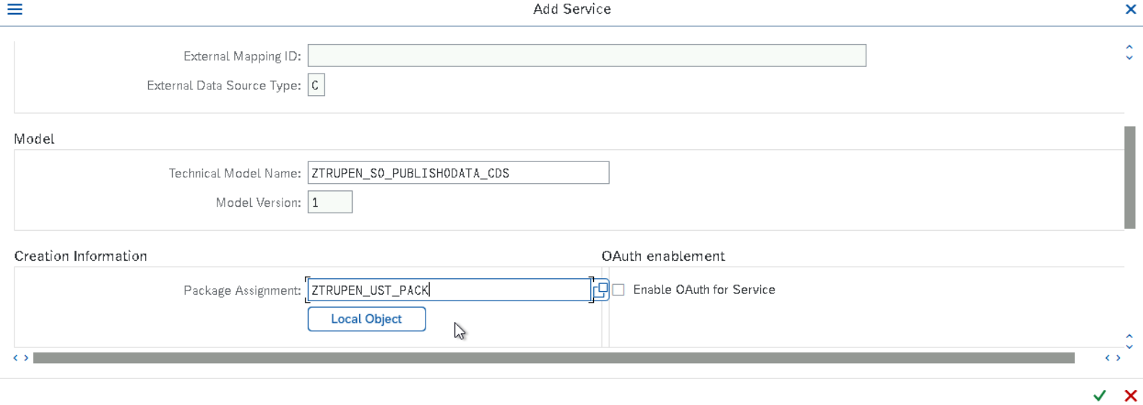

Provide the Transport for the Metadata and Click on Enter.

Provide the transport for the ICF Service and Click on Enter.

Go back to the Service and click on Filter Button and Filter the service name ZTRUPEN_SO_PUBLISH_ODATA_CDS and Click on Enter.

Click on Configure (SICF) under Section ICF Nodes.

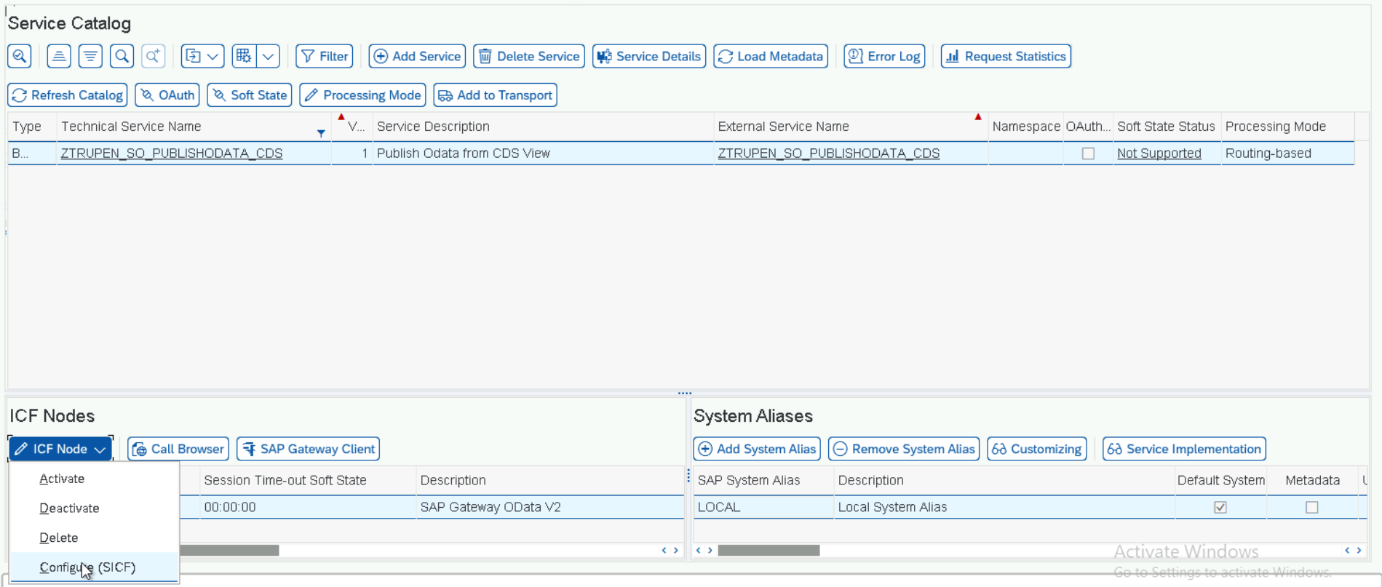

Double click on the Model Name.

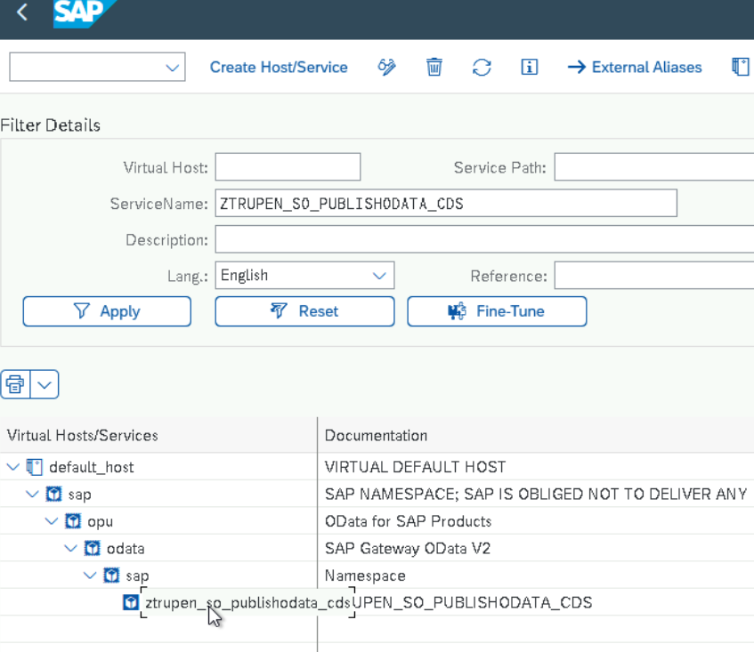

Go In change Mode and Click on the GUI Configuration Button.

Maintain the Parameter to disable the CSRF Token and Click on Execute Button and save.

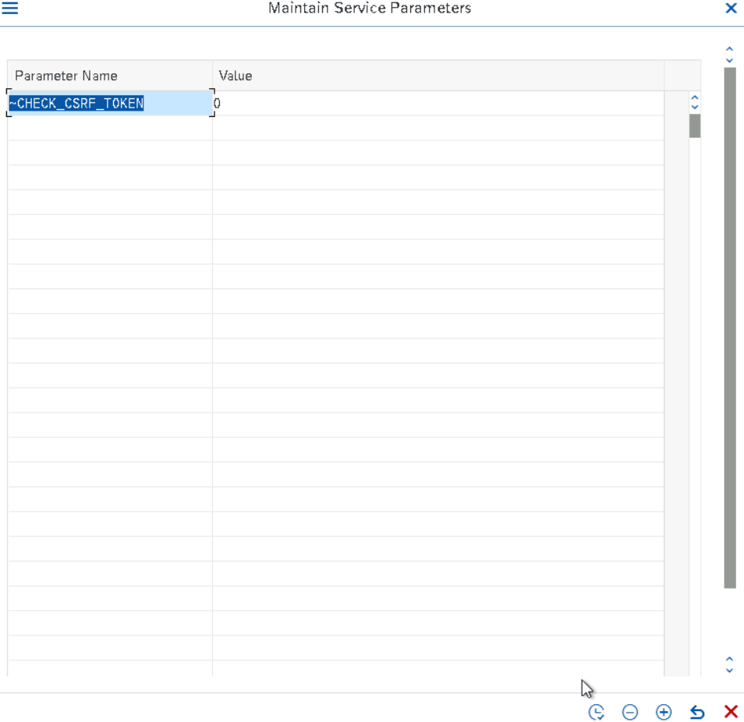

Click on the Execute SAP Gateway client to test the service.

Service activated successfully and the result shows status_code as 200.

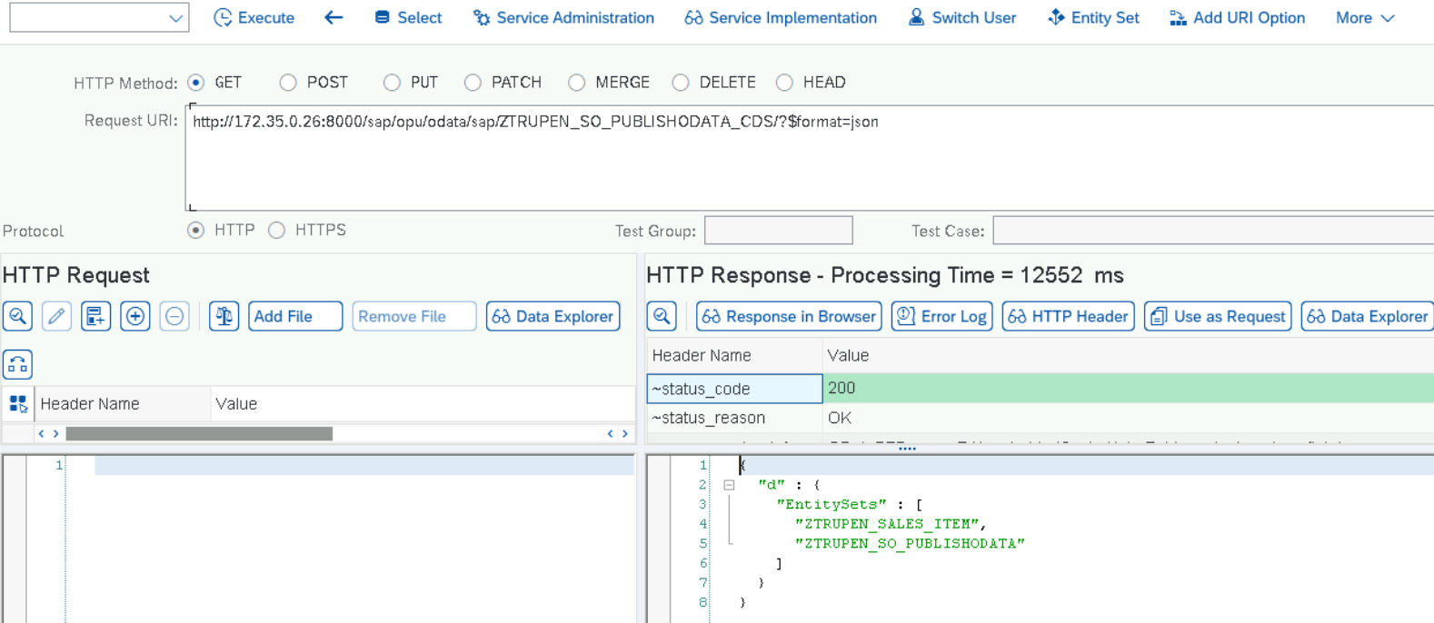

**Testing**

GET Query

URI : http://172.35.0.26:8000/sap/opu/odata/sap/ZTRUPEN_SO_PUBLISHODATA_CDS/ZTRUPEN_SO_PUBLISHODATA('0000004085')?$expand=to_ITEM

